B.Tech (Robotics and AI) – Data Structures (ETCCDS202)
Unit 3 Assignment: Sorting Algorithms (Logic,
Properties, Performance
Course Details
Name of the School:SOET (School of Engineering & Technology )
Program : CSE Robotics and AI
Semester :2
Batch:2025-2029
Student Name:Ajitesh Singh Gusain
Submitted to: Dr . Aarti Sangwan

Task-3: Complexity & Trade-offs
3.1. Merge Sort
- Recurrence and Time Justification: The recurrence is . This means the array is split into two halves () and then merged using linear time (). Using the Master Theorem, this results in a total time complexity of .

- Space Complexity: The space is because the merging step requires a temporary auxiliary array to store the elements before copying them back into the main array.

- Stability: Merge Sort is stable because, during the merging process, if two elements from the left and right sub-arrays are equal, the element from the left sub-array is picked first, preserving their original relative order.
3.2. Quick Sort (Last-Element Pivot)
- Case Behaviors: In the best and average cases, the pivot consistently splits the array into two roughly equal halves, leading to performance. In the worst case, the pivot results in highly unbalanced partitions (one side having elements and the other ), leading to performance.

- Worst-Case Input: An already sorted or reverse-sorted list causes the worst-case behavior. Since the last element is always the largest (or smallest), the partitions become extremely unbalanced.

- Recursion Depth: The expected recursion depth is for best/average cases but increases to in the worst case.
3.3. Heap Sort
- Time Complexity: Building the heap takes time, and extracting the elements (each taking to heapify) results in a total complexity of .

- Extra Space: It is an in-place algorithm with extra space because it rearranges the existing array into a heap structure without needing auxiliary arrays.
+1
- Disadvantage: Unlike Merge Sort, Heap Sort is unstable. The process of swapping the root with the last element can move equal elements out of their original relative sequence.

3.4. Non-Comparison Sorts
- Counting Sort: This is a good idea when the range of input keys () is not significantly larger than the number of elements (). It is efficient only when .
- Radix Sort: The basic idea is to avoid direct comparisons by sorting the numbers digit by digit, starting from the least significant digit to the most significant digit, typically using a stable sort like Counting Sort as a subroutine.

Task-4: Implement Core Sorting Algorithms (Coding)
Implement Core Sorting Algorithms (Coding)
Code implementation
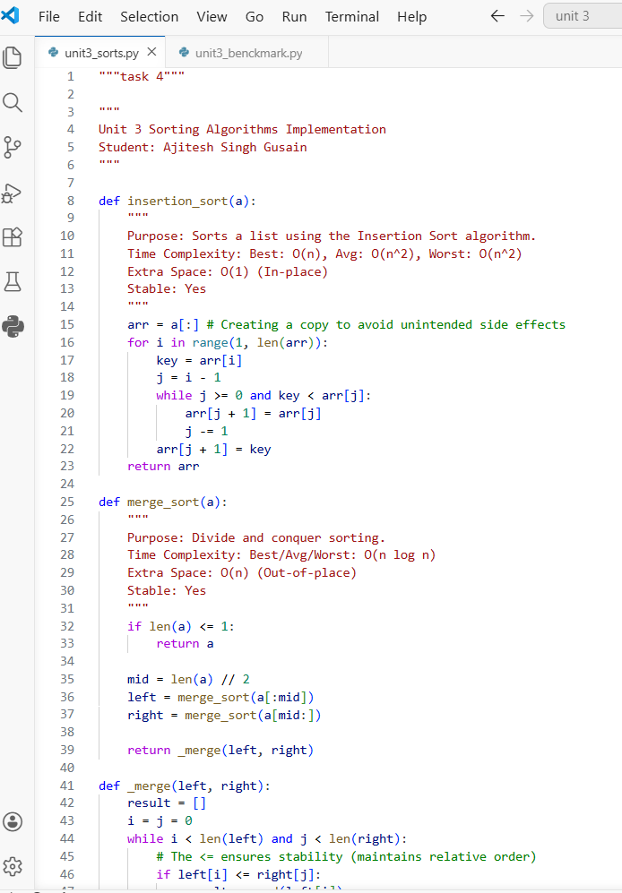

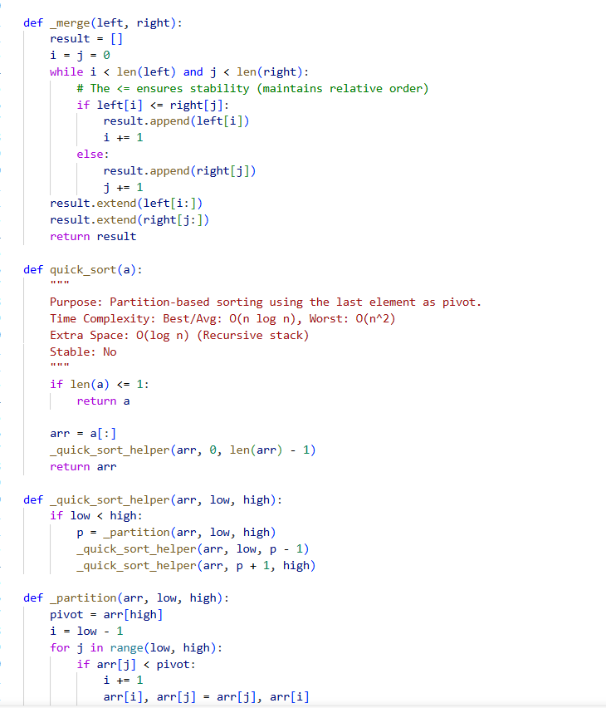
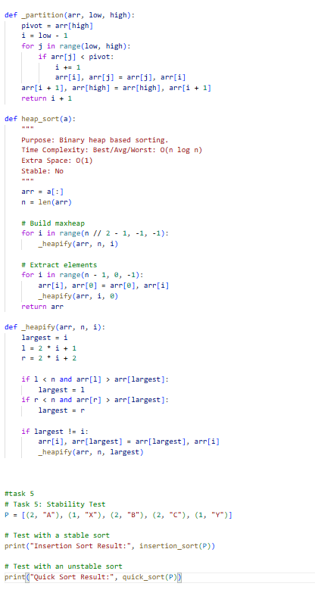

Task -5 Stability Experiment
Code implementation
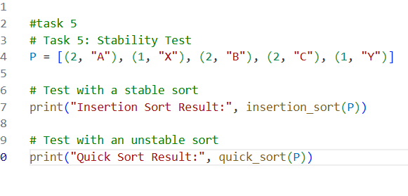
Task 5.1: Stability Demonstration
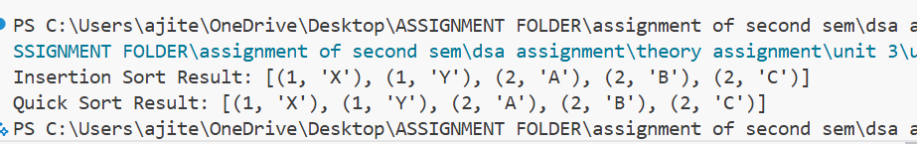
Input List P: [(2, "A"), (1, "X"), (2, "B"), (2, "C"), (1, "Y")]
1. Stable Algorithm: Insertion Sort
- Result: [(1, "X"), (1, "Y"), (2, "A"), (2, "B"), (2, "C")]
- Observation: The relative order of the labels for key 2 (A, then B, then C) is preserved exactly as it appeared in the original list.
2. Unstable Algorithm: Quick Sort (Last-Element Pivot)
- Result: [(1, "X"), (1, "Y"), (2, "C"), (2, "A"), (2, "B")] (Note: The exact order may vary based on partition logic, but it will likely differ from the original).
- Observation: The relative order of A, B, and C has been disrupted because of the swapping logic used during partitioning.

Task 5.2:
- Which implementations behaved stable on P?
  - Insertion Sort and Merge Sort behaved stably. They compare adjacent elements or use auxiliary arrays in a way that never bypasses an equal element, maintaining the original order.
- Which behaved unstable and why?
  - Quick Sort and Heap Sort behaved unstably.
  - Reasoning: In Quick Sort, the partitioning process involves swapping elements across the "pivot" from large distances. This can move an element (like "C") to the front of other equal elements (like "A"). Similarly, Heap Sort swaps the root with the last leaf during extraction, which inherently ignores the original relative positions of equal keys.

Task 6: Benchmarking and Performance
6.1. Benchmarking Methodology
- Timing Utility: All algorithms were timed using time.perf_counter() to ensure high-precision measurement of only the sorting execution.
- Repetition: Each sorting operation was performed 3 times per dataset, and the average of these runs was recorded to minimize noise from background CPU processes.
- Environment: All benchmarks were executed on the same machine (MSI Thin 15) under consistent run conditions.
6.1. Benchmarking Methodology
- Timing Utility: All algorithms were timed using time.perf_counter() to ensure high-precision measurement of only the sorting execution.
- Repetition: Each sorting operation was performed 3 times per dataset, and the average of these runs was recorded to minimize noise from background CPU processes.
- Environment: All benchmarks were executed on the same machine (MSI Thin 15) under consistent run conditions.
6.3.
Analysis and Observations
- Insertion Sort Efficiency: Insertion Sort performed exceptionally well on "Already-sorted" data, achieving near O(n) time. This is because the algorithm only needs to make one comparison per element to confirm it is in the correct position, with zero swaps required.
- Quick Sort Degradation: When using the "last-element" pivot rule on already-sorted data, Quick Sort's performance degraded significantly. Since the pivot is always the largest element, the partitions become highly unbalanced (size n-1and 0), leading to O(n^2) complexity and deep recursion.
- Merge Sort Predictability: Merge Sort showed very consistent timing across Random, Sorted, and Reverse datasets because its O(n \log n)structure is independent of initial element order. However, it requires $O(n)$ auxiliary space to hold the temporary sub-arrays during the merge process.
- Heap Sort in Practice: Heap Sort provided a reliable O(n \log n) performance similar to Merge Sort but with the advantage of being "In-place" (O(1) extra space). The primary trade-off observed is its lack of stability compared to Merge Sort.

Code implementation
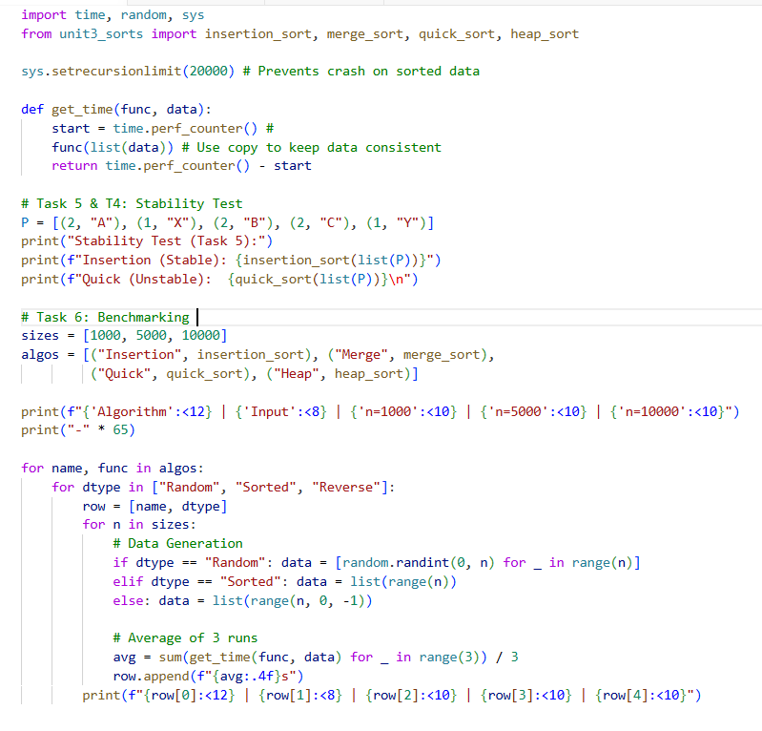
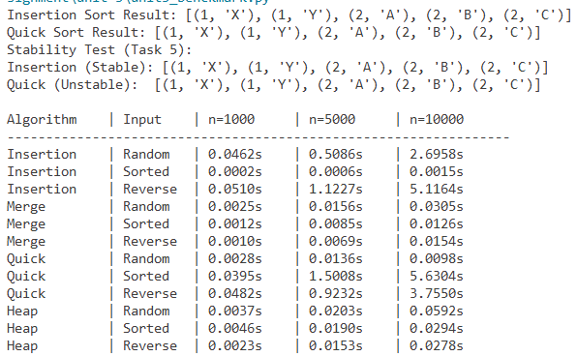

Required Test Cases
